
Story

Date | 23 August 2026
Team ID | --
Project Name | India’s Agricultural Crop Production Analysis (1997–2021)
Maximum Marks | 5 Marks

By using stories in Tableau, complex agricultural data can be presented in a clear and interactive way. The story helps users understand the changes, comparisons, trends, and patterns in India’s agricultural production from 1997 to 2021 through a sequence of visualizations.
In this project, the Tableau Story combines different charts such as maps, pie charts, bar charts, and line charts. These visualizations guide the audience through important aspects of agricultural production, including state-wise production, season-wise production share, crop-wise cultivated area, yearly production, and agricultural yield trends.

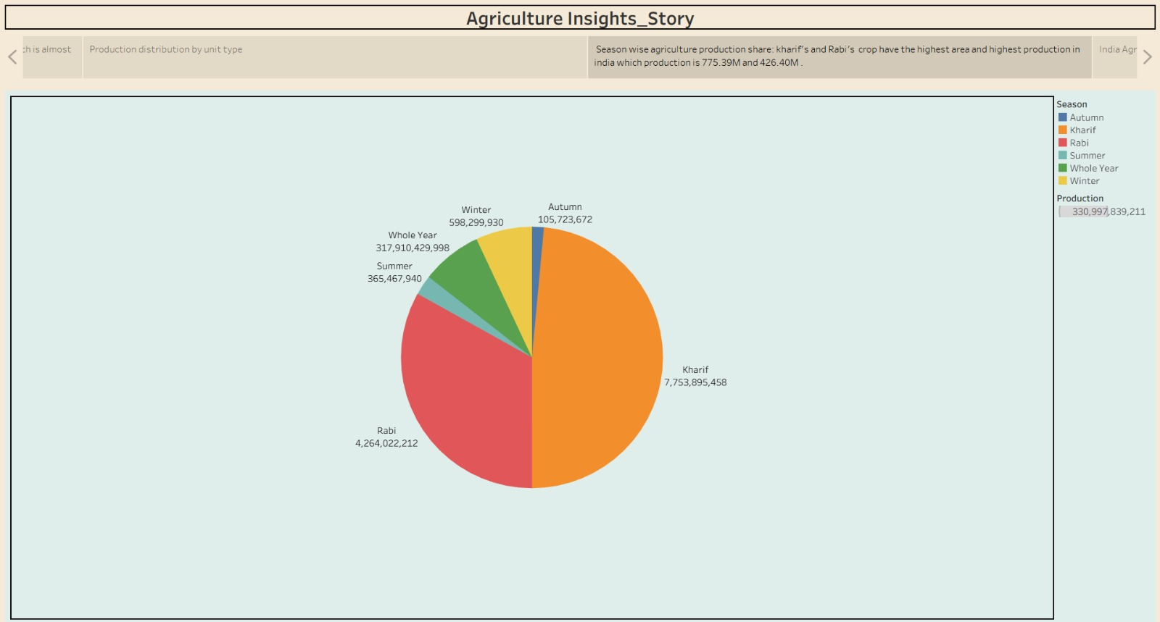

Observations:
- Leading State in Production: Kerala shows the highest agricultural production among the selected leading states, with 129,919,138,501, followed by Tamil Nadu and Karnataka.

- Season-wise Production: The Kharif season has the largest share of agricultural production, followed by the Rabi season, showing their major contribution to overall production.

- Crop-wise Cultivated Area: Wheat has the highest cultivated area among the selected crops, followed by Rice, Soyabean, Bajra, and Cotton.

- Year-wise Production: The year-wise visualization shows changes in total agricultural production during 1997–2021, with production generally increasing over a large part of the study period.
- Yield Trend: Agricultural yield shows considerable variation during the study period, reaching its highest displayed value of 1,577,453 in 2011–12.
- State-wise Area: Uttar Pradesh has the highest cultivated area among the selected states, followed by Madhya Pradesh and Rajasthan.

Activity 2:
Publish Story on Tableau Public link:
https://public.tableau.com/profile/api/publish/Book1_17874992907710/Story1

